11/14/2025
Building an Isolated Blue Team & Digital Forensics Laboratory
A Virtualization Project for Cyber Defence & Monitoring
Lohith.G

About the Author
Lohith G is a cybersecurity practitioner and Bachelor of Computer Applications (BCA) graduate currently enrolled in the Certified Penetration Tester (CPT) program.

With a strong background as a Senior Laptop Service Technician, he possesses deep technical expertise in hardware repair, BIOS configuration, and system recovery. This project integrates his practical knowledge of IT infrastructure with advanced offensive and defensive cybersecurity concepts, demonstrating a capability to design, build, and secure complex virtualized environments.

My Personal DFIR & Blue Team Lab

- Introduction:
Project Objective: To design and build a lightweight, cost-effective, and isolated virtual lab environment using VirtualBox. The lab will serve as a platform for conducting digital forensics investigations, malware analysis, and blue team security monitoring exercises in a safe and controlled manner.

Scope : The lab will initially consist of three core virtual machines: an analyst workstation, a victim/target machine, and a simple network monitoring server. It will be configured on an isolated network to prevent accidental contamination.

Guiding Principles:
- Ethical & Legal: All activities within this lab are for educational purposes only, using authorized software and simulated scenarios.
- Isolation: The lab network must be segregated from the host machine's primary LAN.
- Repeatability: The lab must be easily reset to a "clean" state using VM snapshots.
- Documentation: Every step, from network design to tool installation, will be documented here.

- Lab Architecture:
2.1 Host Hardware : ThinkPad X13 (Intel i5-10310U, 16 GB RAM)
2.2 Host Software : Windows, VirtualBox (v6.x or v7.x).
2.3 Virtual Network Design :
We will use a VirtualBox "Host-Only Network" (e.g., vboxnet0).

Purpose : This creates a private network that includes your host machine and all the lab VMs. It's isolated from your home router and the internet, which is critical for safety.

IP SCHEMA :
- Network: 192.168.56.0/24
- Host Adapter (vboxnet0): 192.168.56.1 (Your "gateway" for managing VMs)
- Analyst VM: 192.168.56.101
- Victim VM: 192.168.56.102
- Server VM: 192.168.56.103

Lab Architecture

VM Name | Operating System | Purpose | vCPUs | RAM | Network Adapter
ANALSYT-VM | SIFT Workstation (Ubuntu-based) | Forensic analysis, Wireshark, Volatility, etc. | 2 | 4-6 GB | Host-Only (vboxnet0)
VICTIM-VM | Windows 10 (Evaluation) | The "target" machine for analysis (e.g., malware, log collection) | 2 | 2-4 GB | Host-Only (vboxnet0)
LOGGER-VM | Ubuntu Server 22.04 | Central log collection (Syslog-NG, basic ELK, or T-Pot) | 2 | 2-4 GB | Host-Only (vboxnet0)

- Lab Setup: Phase 1:

Configure VirtualBox Networks :
- In VirtualBox: File > Host Network Manager
- Click Create
- Select the new adapter (e.g., vboxnet0)
- Set the IPv4 Address to 192.168.56.1 and Netmask to 255.255.255.0.
- Go to the DHCP Server tab and uncheck Enable Server. We will set static IPs for full control.
Download ISOs:
SIFT Workstation(Lab) : SIFT Workstation | SANS Institute
Windows 10/11 Enterprise(Victim) : Windows 11 Enterprise | Microsoft Evaluation Center
Ubuntu Server(Logging) : Get Ubuntu Server | Download

- Lab Setup: Phase 2 (Build and Isolate)
This section details the step-by-step build, configuration, and isolation of each lab VM.

  - ANALYST-VM(SIFT WORKSTATION)
Objective: To import the official SIFT OVA (appliance), establish a baseline snapshot, and then isolate it onto the lab network with a static IP.
File Used: sift-22.04-20240201.ova
Base VM Settings (from import):
- RAM 8GB
- vCPU 4
- HDD 80GB
- Import and Baseline Snapshot:
- Imported the SIFT Workstation .ova file via File > Import Appliance
- Added an Optical Drive : Before the first boot, I went to the settings > Storage, selected the IDE Controller, and clicked "Adds optical drive" to allow Guest Additions to be mounted.
- Network : Left the adapter on default NAT to allow internet access for updates.

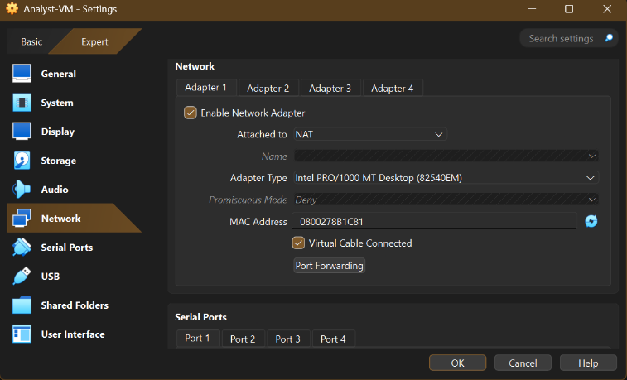

- Start the VM(Login : Sans forensics and password : forensics)
- Installed Guest additions : Clicked Devices > Insert Guest Additions CD Image and ran the installer from the terminal to enable clipboard and screen resizing.



- Ran System Updates : sudo apt update , sudo apt upgrade -y
- Shutdown the VM
- Took Snapshot (Clean Install(Internet)), This serves as our master "template" for the SIFT workstation.

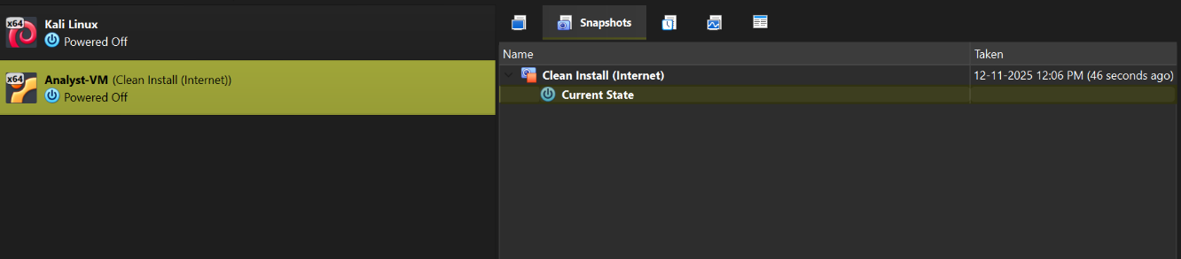

- Successfully Installed SIFT :
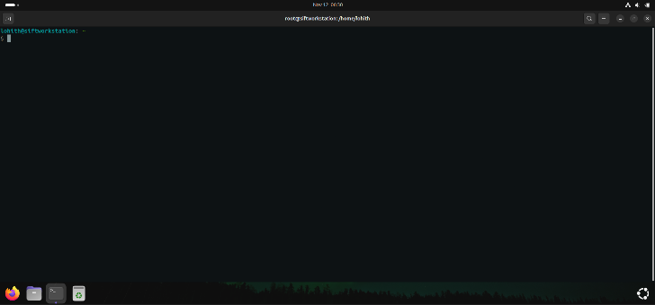
- Lab Isolation(Host-Only) :
  - Changed the VM’s network adapter from NAT to Host-Only Adapter

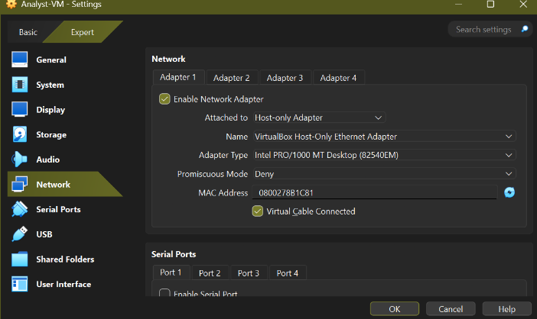

  - Started the VM
  - Identified the network adapter(enp0s3) and created the netplan configuration to set a static IP
  - Applied the netplan configuration using sudo netplan apply
  - Verified Connectivity

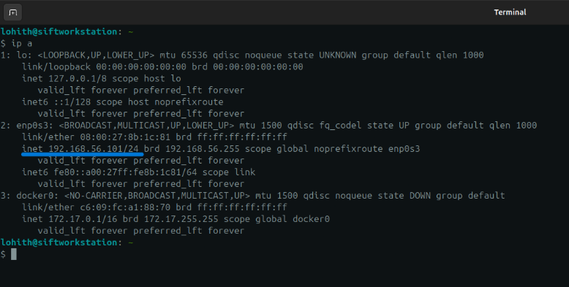

  - Ping Host Check :

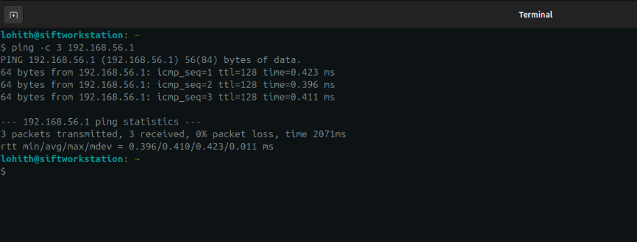

  - Shut down the VM and took Snapshot – Isolated Lab(Static IP)

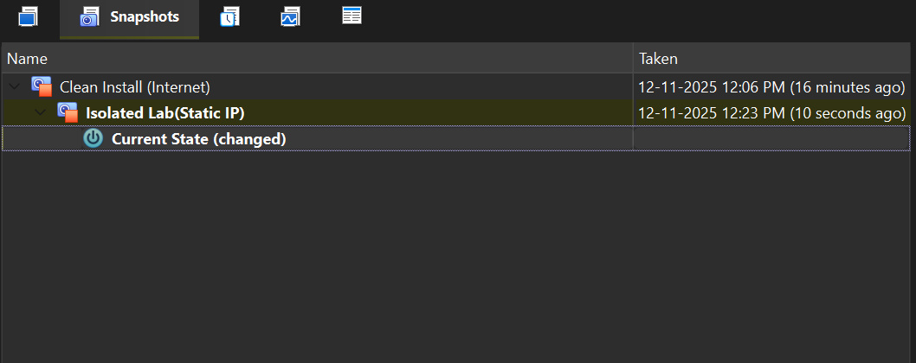

  - LOGGER-VM (Ubuntu Server):
- Objective : To build a lightweight server, pre-install syslog-ng for log collection, and isolate it with a static IP.
- ISO Used : Ubuntu-24.04-live-server-amd64.iso
Base VM Settings:
- RAM : 2GB
- vCPU’s : 2
- HDD : 20GB
    - Internet Phase Build :
- Created a VM named Logger-VM with NAT
- Installed Ubuntu Server 24.04 server . During setup, selected “Install OpenSSH Server” to allow remote management.
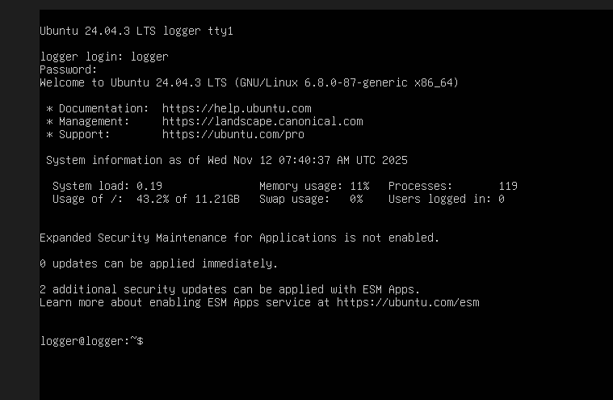

- Once installed, logged in and installed syslog-ng , removing the default rsyslog to prevent conflicts:
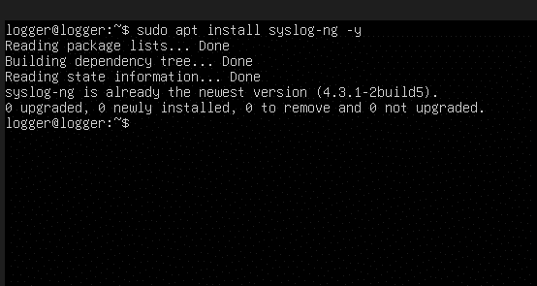

- Shutdown the server using sudo shutdown now
- Took Snapshot Clean Install(Internet)

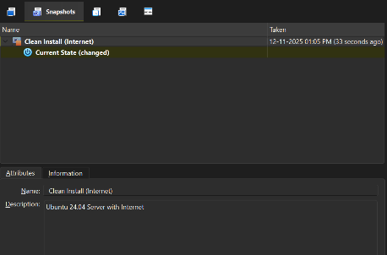
    - Lab-Phase Isolation (Host-Only) :
- Changed the VM’s adapter from NAT to Host-Only Adapter

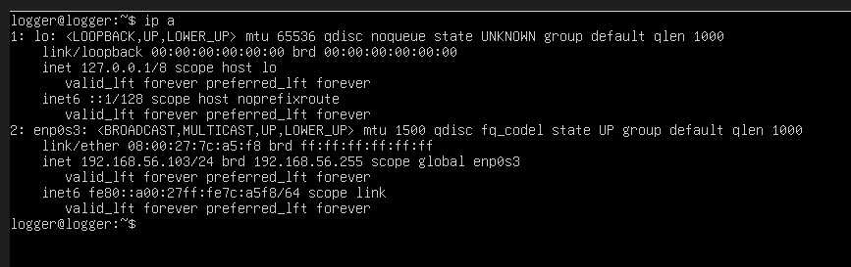

- Started the VM and identified the adapter name
- Set the static IP by creating /etc/netplan/01-netcfg.yaml :

network:
version: 2
renderer: networkd
ethernets:
enp0s3: #<-- Adapter name
dhcp4: no
dhcp6: no
addresses:
- 192.168.56.103/24
gateway4: 192.168.56.1
nameservers:
addresses: [1.1.1.1]

- Applied the configuration using sudo netplan apply
- Verified connectivity to the host and the ANALYST-VM

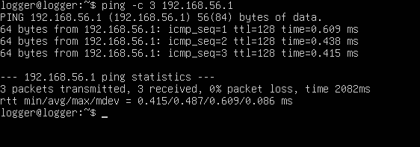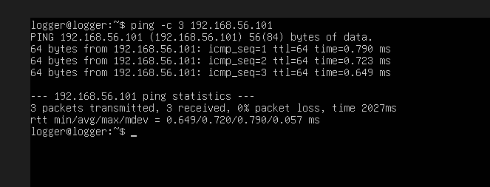

- Shutdown the server and took snapshot Isolated Lab(Static IP)

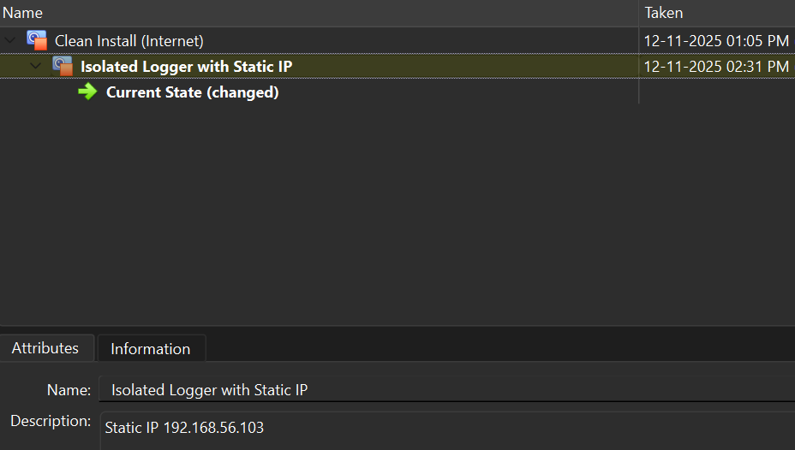

  - VICTIM-VM (Windows 11 LTSC):
- Objective : To build a "victim" workstation, pre-install monitoring tools, and isolate it with a static IP.
- ISO Used : Windows-11-LTSC-2024-Eval.iso
- Base VM :
- RAM : 4GB
- vCPU’s : 2
- HDD : 60GB

  - Internet-Phase Build :
- Created a VM named VICTIM-VM with its network adapter set to NAT to provide internet for setup.
- Installed Windows 10 LTSC from the ISO. During setup, selected "Offline account" to create a local user.
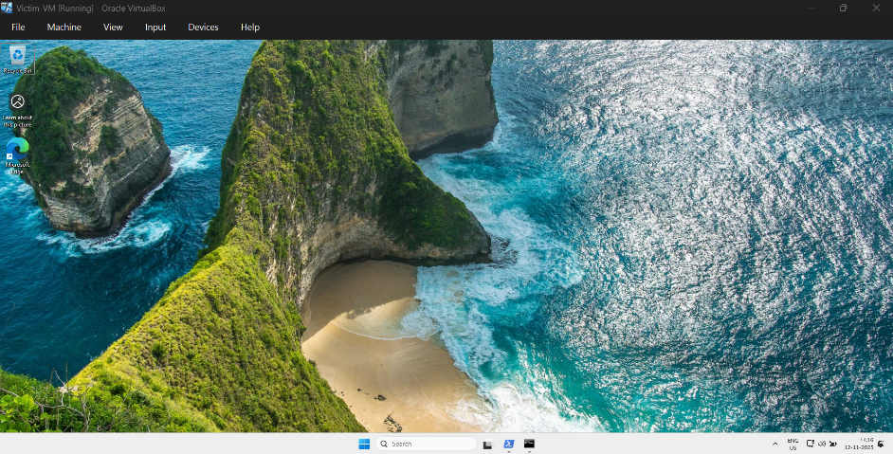

- Installed VirtualBox Guest Additions (VBoxWindowsAdditions-amd64.exe) to improve performance and enable drag-and-drop.
- Downloaded and extracted the Sysinternals Suite.
- Installed Sysmon using an Admin PowerShell to provide deep system logging

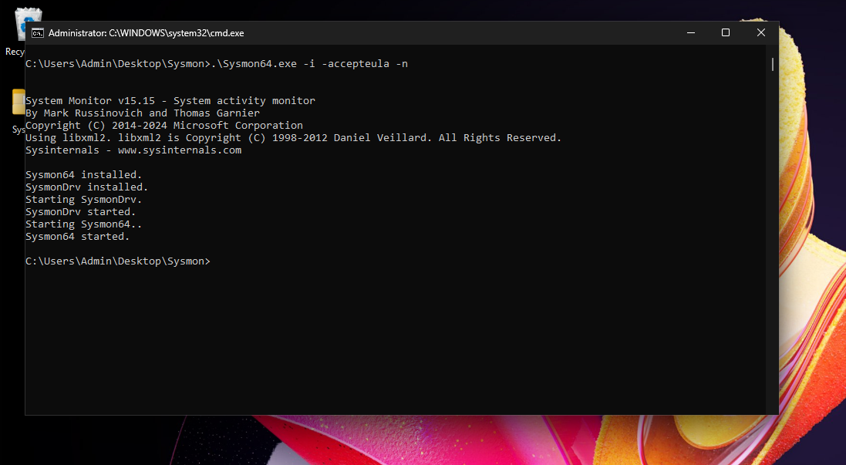

- Shut down the VM from the Start Menu.
- Took Snapshot - Clean Install (Internet). This serves as the master "template" for the victim machine.
  - Lab-Phase Isolation (Host-Only) :
- Changed the VM’s adapter from NAT to Host-Only Adapter

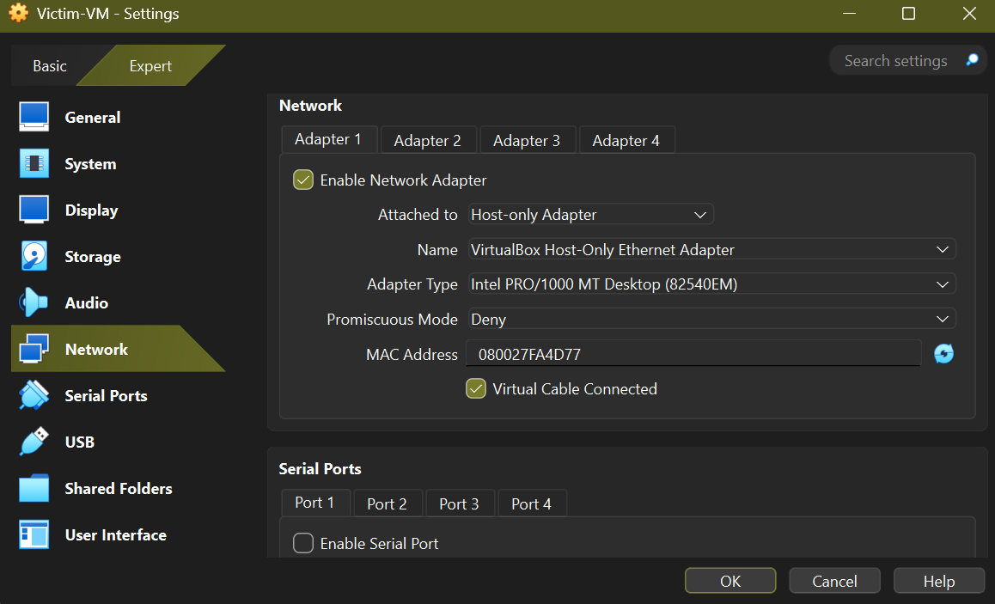

- Started the VM and configured the static IP using the ncpa.cpl GUI :
- IP address : 192.168.56.102
- Subnet Mask : 255.255.255.0
- Gateway/DNS : Left Blank
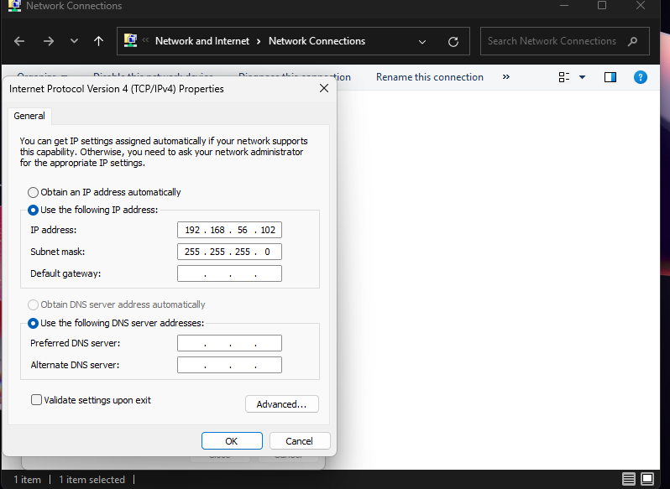

- Enabled ICMP (ping) in the Windows Defender Firewall to allow discovery from other lab VMs:
- Using Enable-NetFirewallRule -DisplayGroup "File and Printer Sharing"
- Verified connectivity to the host (.1), ANALYST-VM (.101), and LOGGER-VM (.103).
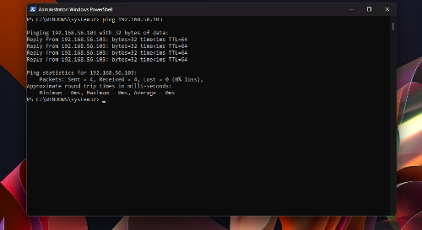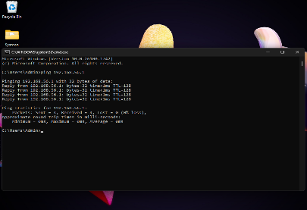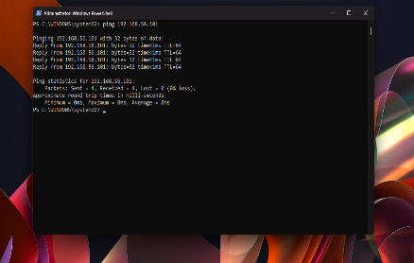
- Shut down the VM and took Snapshot-Isolated Lab(Static IP)
- Lab Setup: Phase 3 (Live Configuration)
This phase details the configuration of services to connect the lab VMs, establishing the centralized logging pipeline. All VMs are started from their Isolated Lab (Static IP) snapshots.

  - Configuring the LOGGER-VM (syslog-ng) :
  - Started the LOGGER-VM from its snapshot.
  - Created a new configuration file to tell syslog-ng to accept network logs:
FILE -> /etc/syslog-ng/conf.d/net-listen.conf

source s_network {
network(ip("0.0.0.0") port(514) transport("tcp"));
network(ip("0.0.0.0") port(514) transport("udp"));
};

destination d_remote_logs {
file("/var/log/remote/$HOST/$PROGRAM.log"
owner("root") group("root") perm(0600) create_dirs(yes)
);
};

log {
source(s_network);
destination(d_remote_logs);
flags(final);
};

- Manually created the remote directory to ensure permissions were correct:
sudo mkdir -p /var/log/remote.
- Restarted the service : sudo systemctl restart syslog-ng
- Verified the listener : sudo ss -tulpn | grep 514

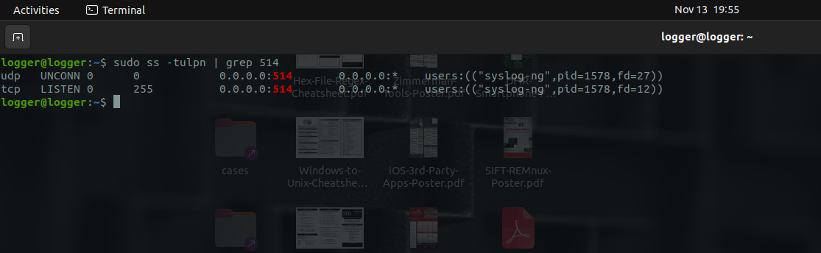

  - Configuring the VICTIM-VM(NXLOG)
- Started the VM.
- Installed NXLOG Community edition.
- Configured C:\Program Files\nxlog\conf\nxlog.conf to collect standard Event Logs and Sysmon logs, forwarding them to 192.168.56.103
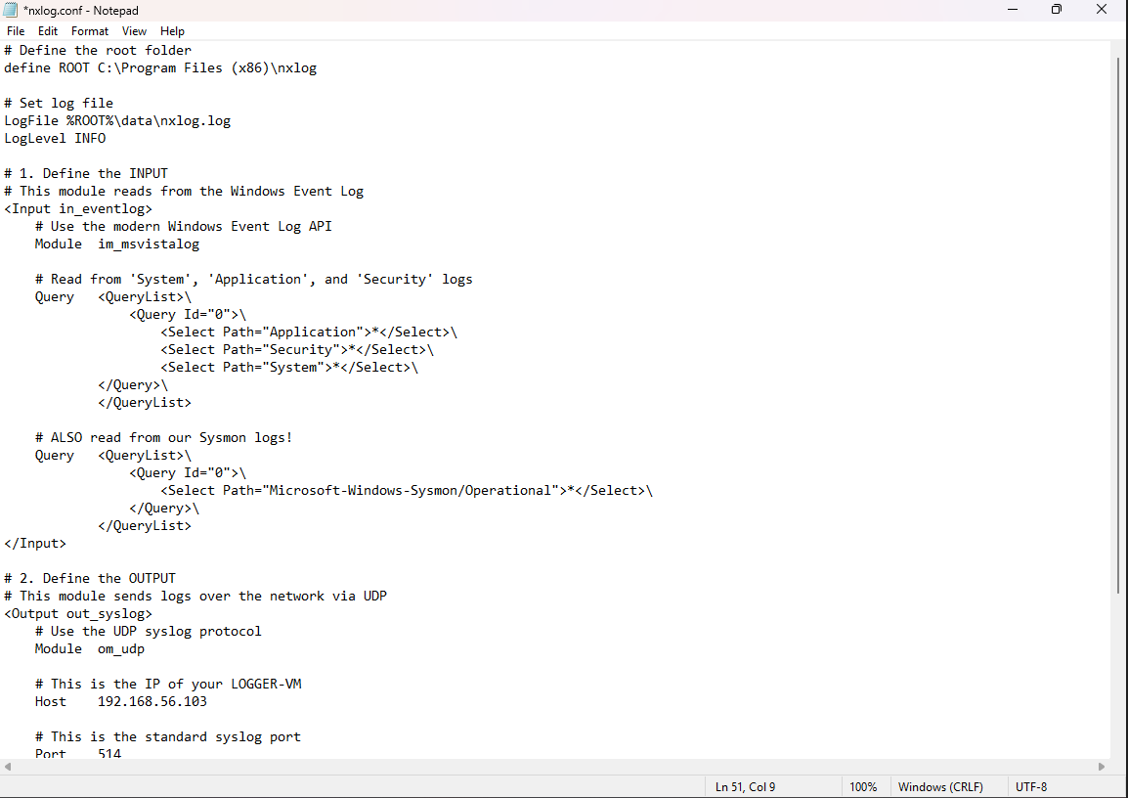

- Started the nxlog service

  - Verifying the Log pipeline :
- Generated "noise" on the VICTIM-VM by running whoami in PowerShell.

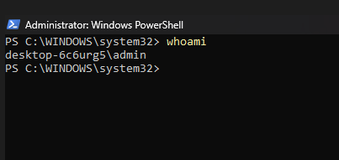

- On the LOGGER-VM, monitored the incoming logs in real-time:
- Using sudo tail -f /var/log/remote/192.168.56.102/nxlog.log
- Success: Confirmed that Sysmon "Process Create" events (Event ID 1) for whoami.exe appeared instantly on the logger.

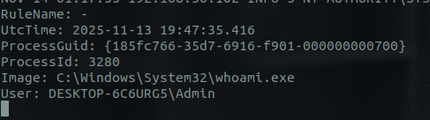

- Standard Operating Procedures (SOP) :
To maintain lab integrity and ensure a consistent testing environment, the following procedures must be followed.
  - Lab Start-Up Routine
- Open VirtualBox.
- Start the LOGGER-VM first. This ensures the listener is ready before logs start arriving.
- Start the VICTIM-VM
- Start the ANALYST-VM
- Verify the pipeline by checking the live log stream on the Logger:
- sudo tail -f /var/log/remote/192.168.56.102/nxlog.log
  - Lab Reset Routine (Crucial)
- Shutdown all VMs.
- For each VM, go to the Snapshots tab.
- Right-click the v2.1 - Isolated Lab (or latest working) snapshot.
- Select RESTORE.
- Uncheck "Create a snapshot of the current machine state"
- Click Restore. This guarantees that every new lab session begins with a mathematically identical, clean baseline.

- Future Roadmap :
This project lays the foundation for advanced cybersecurity scenarios. Future enhancements planned for this lab include:

Offensive Integration: Adding a Kali Linux VM (192.168.56.104) to the isolated network to simulate active attacks (brute force, exploits) against the Victim VM.

Visualization: Upgrading the LOGGER-VM to run Elasticsearch and Kibana (ELK Stack). This will replace the raw text logs with a graphical dashboard to visualize attacks.

Malware Analysis: Creating a dedicated "Detonation" snapshot for the VICTIM-VM with Windows Defender disabled, allowing for static and dynamic analysis of real malware samples.

Active Directory: Promoting the VICTIM-VM to a Domain Controller or adding a Windows Server VM to practice AD attacks (Kerberoasting, Golden Ticket).

- CONCLUSION :
This project successfully established a functional, isolated, and professional-grade Digital Forensics and Incident Response (DFIR) laboratory. By leveraging virtualization, we created a secure environment that mimics a real-world corporate network.
Key achievements include:
- Full Isolation: Implementation of a Host-Only network (192.168.56.0/24) ensures that simulated threats cannot escape to the host or internet.
- Deep Visibility: Integration of Sysmon allows for granular kernel-level monitoring of process creation, network connections, and file modifications.
- Centralized Logging: The NXLog and syslog-ng pipeline successfully forwards logs in real-time, enabling "over-the-shoulder" monitoring of the victim machine.
- Forensic Readiness: The SIFT Workstation is configured and ready for disk image and memory analysis.
This lab now serves as the primary workspace for Certified Penetration Tester (CPT) studies and practical skill development.

- References & Tools Used
• VirtualBox: Oracle VM VirtualBox (Hypervisor)
• SIFT Workstation: SANS Institute (Forensics)
• Ubuntu Server 24.04 LTS: Canonical (Log Server)
• Windows 10 Enterprise LTSC: Microsoft (Target OS)
• Sysinternals Suite (Sysmon): Microsoft
• NXLog Community Edition: Log Forwarding Agent
• Syslog-ng: Log Collection Daemon

